****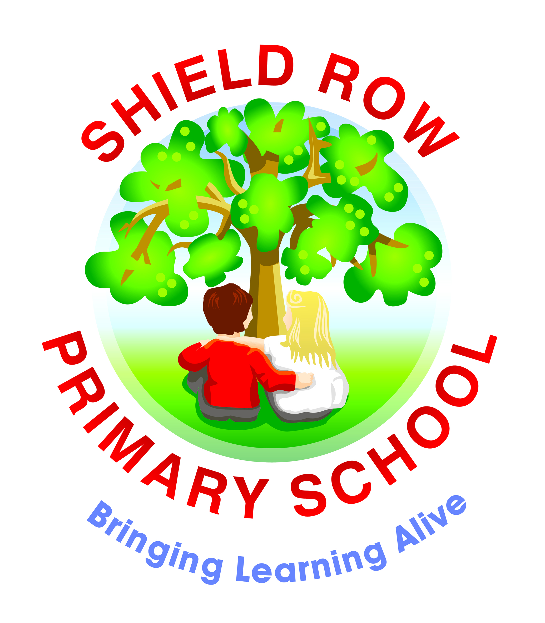

**Shield Row Primary School**

**Year 5’s Pick ‘n’ Mix Homework: COASTS**



**Our theme this term is ‘COASTS’ – we will be investigating how coasts are formed and shaped, land use, industry, coastal erosion, coastal management, undertaking fieldwork at Robin Hood’s Bay, comparing and contrasting localities.**

**Each week choose one piece of homework from a new box. Homework is to be handed in every FRIDAY.**

**In the table below, you will find a range of different tasks to complete. Choose at least one to complete each week.**

**\*\*On-going homework: 100 Word Challenge, Reading, Spelling and Times Tables Practice – see our ‘Class Blog’ for details.**

|  |  |  |
| --- | --- | --- |
| Build a model of a Yorkshire Coble | Write a poem about the sea | Create an A-Z fact-file of creatures found in rock pools |
| Create a ‘coast’ themed word-search or crossword | Create a ‘coast’ themed board game – include coastal facts | Who and what were smugglers?  Write your own adventure story. |
| Find out about the daily tide times at Whitby/Robin Hood’s Bay.  When is it safe to visit the beach? | Create your own Professor Know-it –all’s one minute  ‘Guide to Coastal Erosion’ | Create a beach safety guide.  Find out what the flags used by lifeguards represent. |
| Find out about the RNLI.  What do they do? Why is it such an important charity? | Make a poster to persuade tourists to visit Robin Hood’s Bay | Express yourself – seaside art – use your imagination! |
| Use an atlas to plan a route from Stanley to Robin Hood’s Bay or another seaside locality. How far is it? How long would it take? | What are fossils? How are they formed? Create your own identification chart. | Which other seaside localities in the UK have you visited? Create and write a postcard describing where it is and what it is like there |

Kind regards,

Mrs Henderson